**SOFTWARE ENGINEERING**

**Q1. What is Software? What is Software engineering?**

* **Software:**

Ans: software is a set of instructions (Input), to be executed (process), for specific task(output).

* **Software engineering :**

Ans: Software engineering is a process to develop any software based on the engineering principles.

**Q2. Explain types of software?**

**Types of Software**

**1)System Software :**in build system, this software is no need to install or Download. It is already provided by the system itself.

EX: Notes , Web browser , Google etc..

**2)Application software :** This Software dependent to user or Developers. Need to install or Download in your system to use and it provided by developers.

EX : Instagram , Games , Telegram etc..

**3) Driver Software :** This Software communication between application and hardware and sharing high software.

EX : Audio Driver , Video Driver , Graphic Card etc..

**4) Middleware :** communication or mediates between System Software and Application Software.

EX : Ms Word , Excel etc..

**5) Programming Software :** Developers use to this software to write, read and Execute a code .

EX : Visual Studio Code , Dev C++ , Anaconda etc..

**Q3.What is SDLC? Explain each phase of SDLC?**

Ans. SDLC full form as a Software Develop life cycle as a step by step approach to Developn any software with Quality , in shortest time and within the estimated budget.

**Each Phase of SDLC:**

**1) planning / requirement gathering :** The developer collects Requirements from the client or Company to paln the project.

**2) Analysis :**Developer Analysis the requirements and creates a Software Requirements (SRC) , ensuring no changes.

**3) Designing :** developer work from designing , different3d model , ER diagram , User Case diagram , flowchart , data flow diagram etc..

**4) Implementation/development/building :** developer work from backend side a project implementation or development.

**5) Testing :**The Developer meets the client to tested the project and client check the work is correctly success.

**6)Maintenance :** maintain the project according to the developer Time prior.

**Q4. What is DFD ? Create a DFD Diagram on Flip Kart ?**

* DFD also Know as data flow diagram.
* A graphical tool , useful for communicating with users , managers and other personnel.
* DFD also known as Bubble Chart.

**Components of DFD:**

* Process
* Data Flow
* Data Store
* External Entity

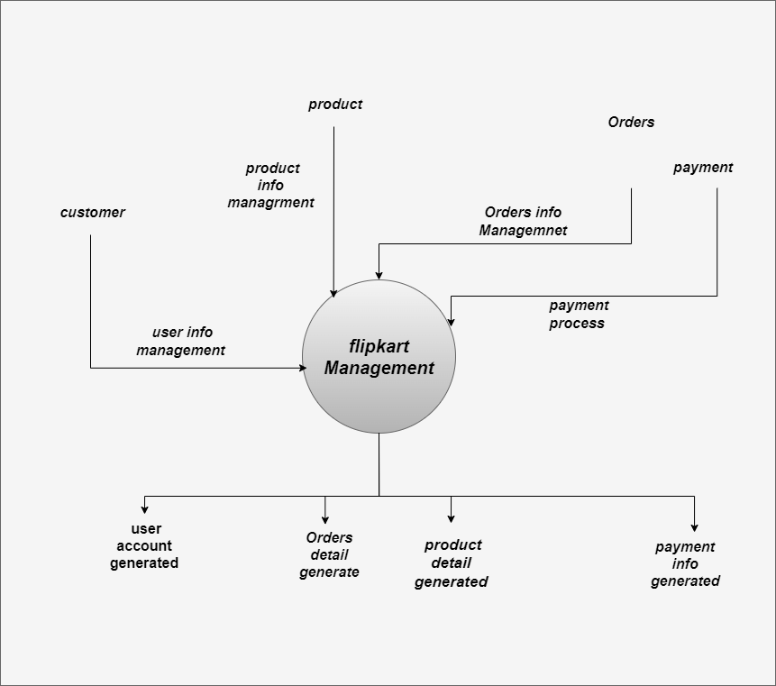

**Level-0 DFD of Flip Kart Management system**

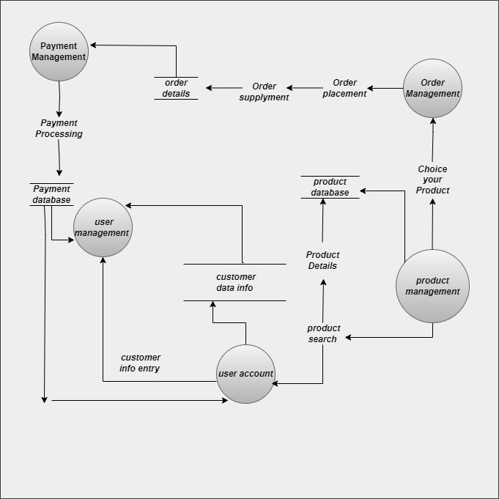

**Level-1 DFD of Flip Kart Management system**

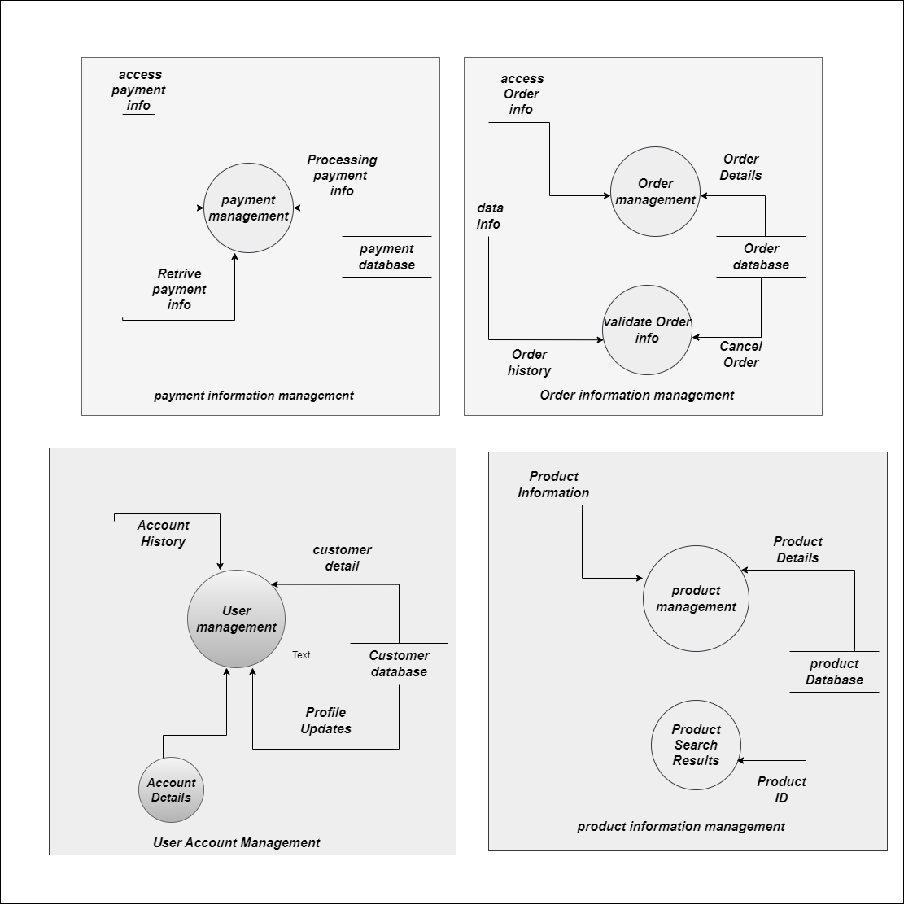

**Level-2 DFD of Flip Kart Management system**

**Q5. What is Flow Chart? Create a Flow Chart to make addition of two Numbers ?**

**Ans.** A Flow Chart is a Diagram that Graphical representation of algoritham.

* A Flow Chart is use to symbols , Shapes and Arrows in process.
* Flow chart is step by step process and solve a task to easily understand and make a decision.

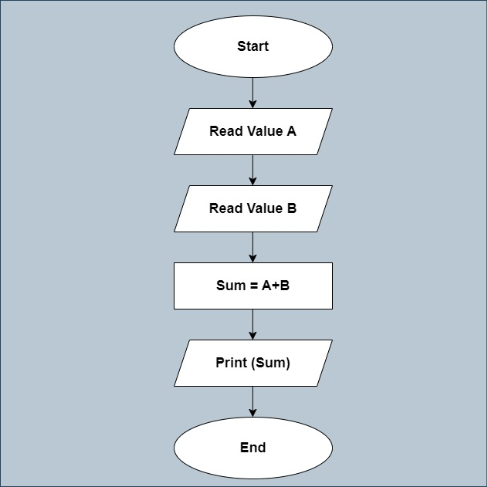

**Q6.What is Use Case Diagram ? Create a use case diagram On Bill payment on paytm ?**

Ans. Use Case diagram is a Seqaunce of Actions Performed by the Actors.

* Use Case Diagram is use to how process is solve in Sequnace of steps in your task.
* Mainly 3 types of components:
* Actor
* Use Case
* Association

